GitHub: KhanhTaiTran/Web-Application-Lab
Task 5.1: Multi-criteria Search + Task 5.2: Category Filter
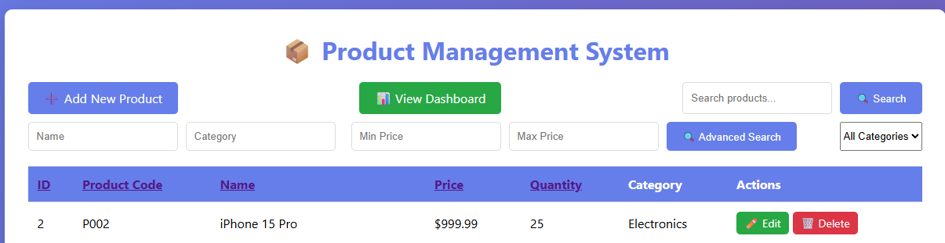
List product by category:
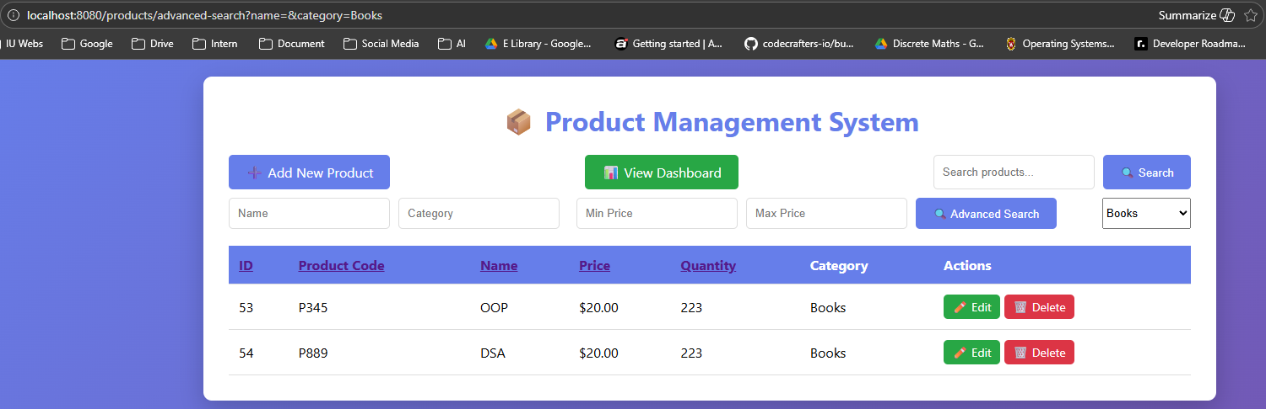
Advance search for electronics and min = 50 , max = 200
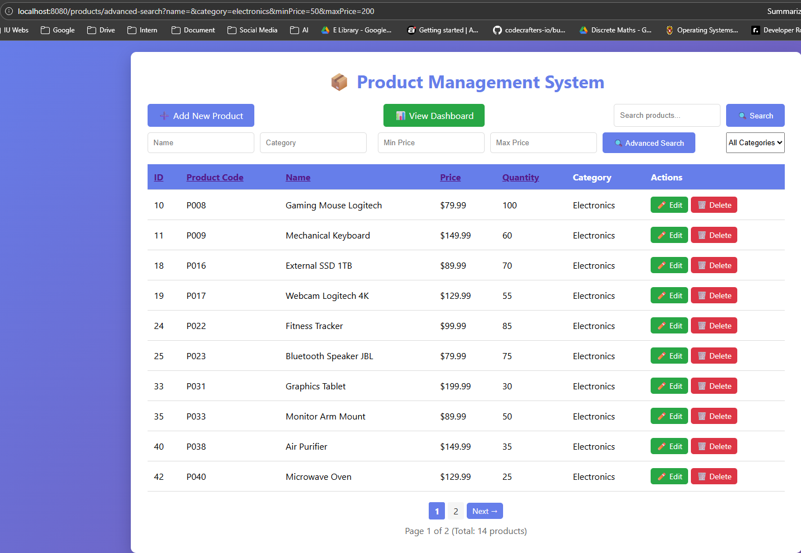
Task 5.3: Search with pagination
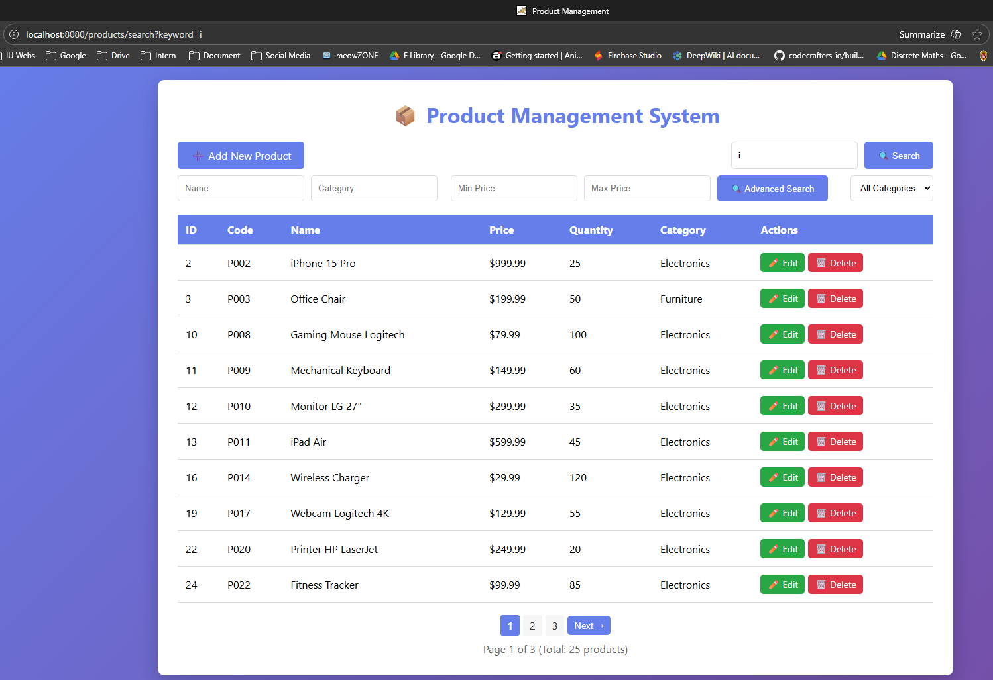
In repository layer:
Create Page<Product> to return a page not all list of product like List<Product>
In service layer:
Create Page<Product> searchProductWithPage(String keyword, Pageable pageable)

In controller layer:
@GetMapping("/search")
public String searchProducts(
@RequestParam("keyword") String keyword,
@RequestParam(defaultValue = "0") int page, // ← current page
@RequestParam(defaultValue = "10") int size, // ← # items each page
Model model) {

// create object
Pageable pageable = PageRequest.of(page, size);

Page<Product> productPage = productService.searchProductsWithPage(keyword, pageable);

//add to model
model.addAttribute("products", productPage.getContent());
model.addAttribute("currentPage", page);
model.addAttribute("totalPages", productPage.getTotalPages());
model.addAttribute("totalItems", productPage.getTotalElements());

return "product-list";
}
How it work:
- Browser > Get/products/search?keyword=i
- Controller get the parameters
  - Keyword = i
  - Page = 0 (default)
  - Size = 10 (default)
- Create pageable object (show page 0, each page 10 items)
- Service call productService.searchProductsWithPage()
- JPA auto execute
- So we can created page object
- Add data into model
- Thymeleaf render HTML page with pagination controls
- Send to browser

Task 6: validation:
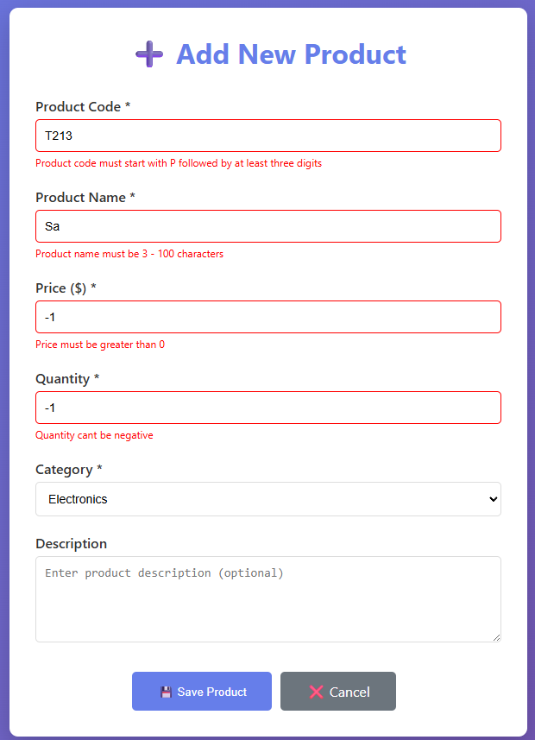
Task 7: Sorting and filtering
Task 8: DashBoard
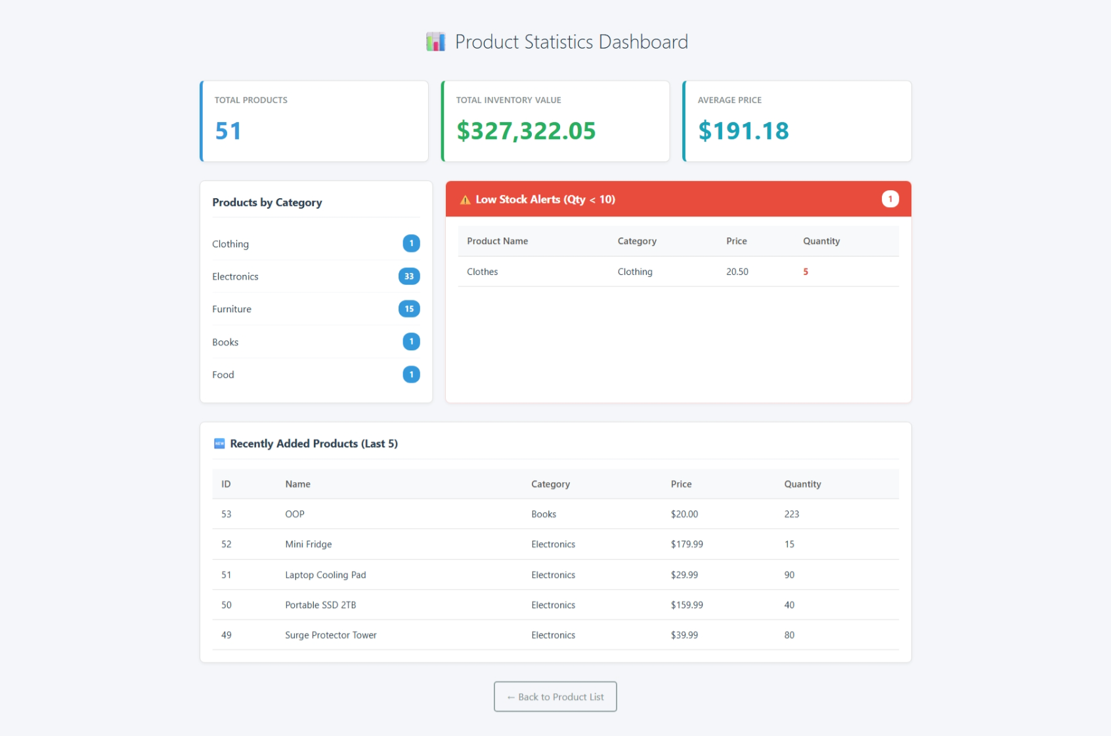
Bonus 1: Rest API
Test GET (get list of products)
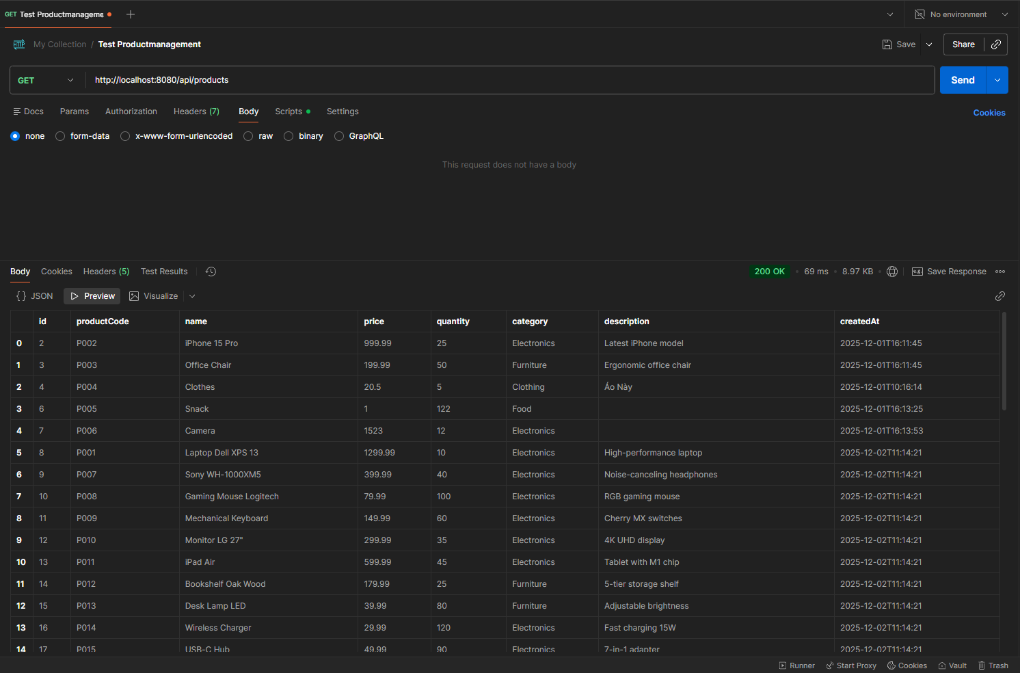
Test POST:
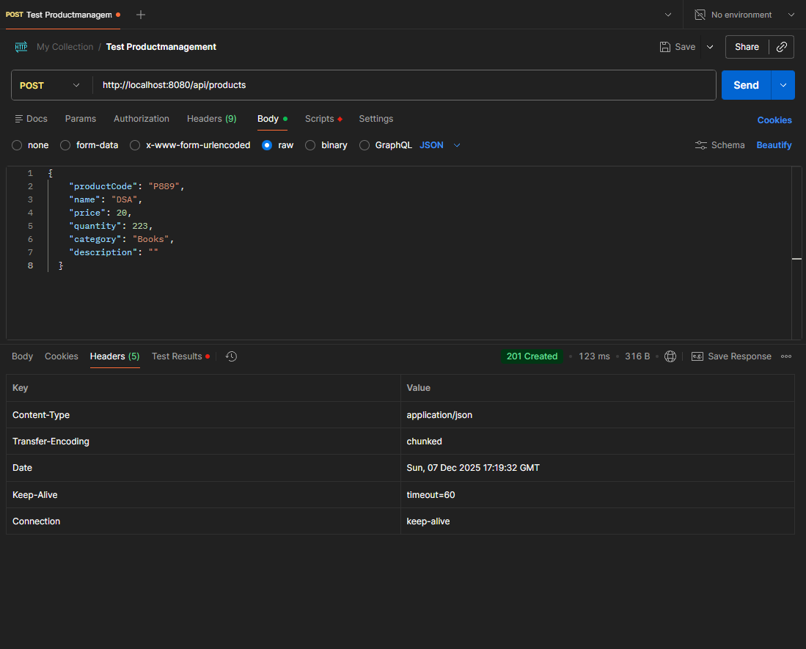

Test PUT (update product)
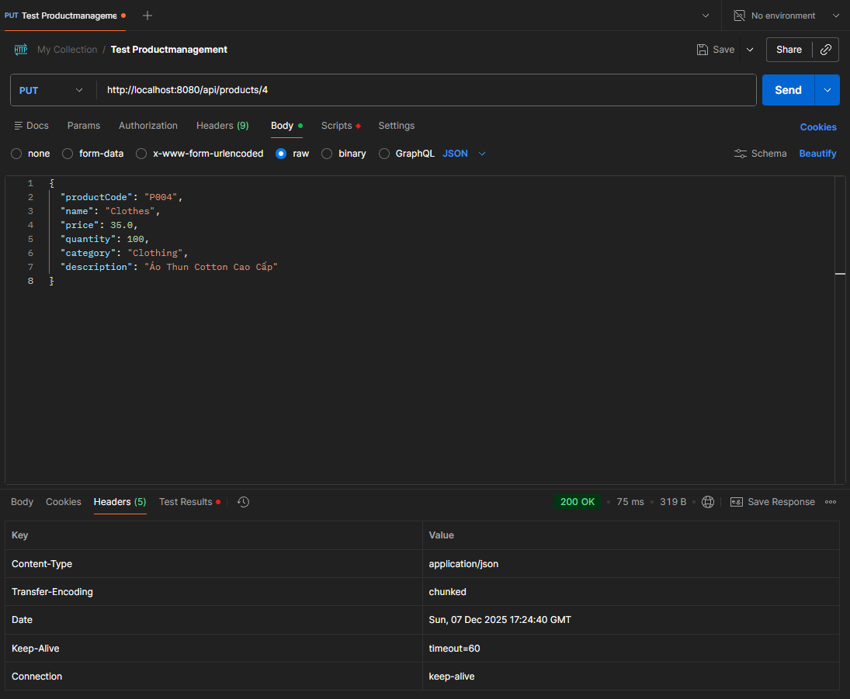

Test Delete:
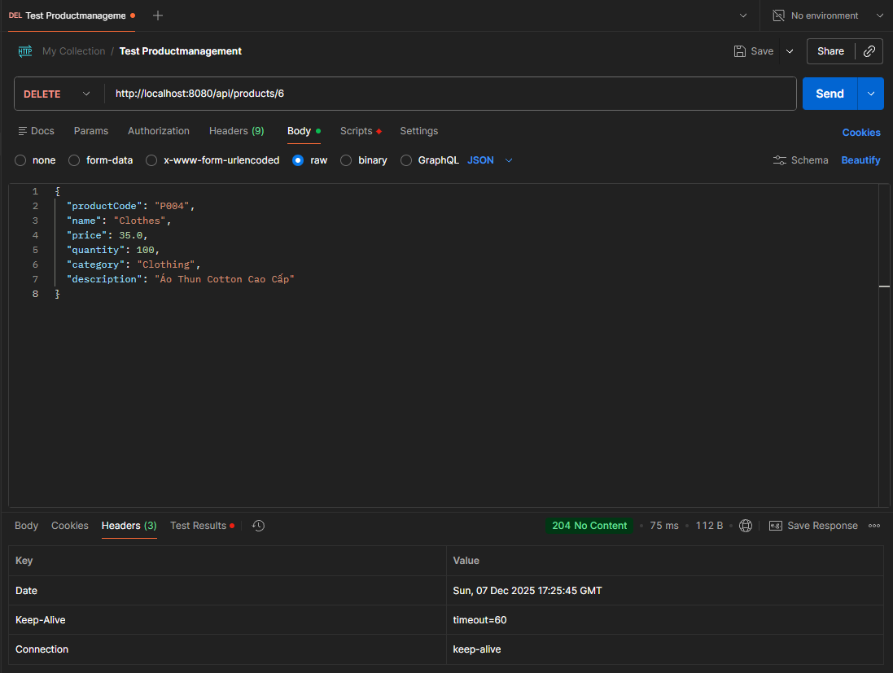
Test single product:
